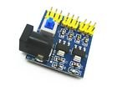**DC-DC 12V to 3.3V 5V Power Module 3.3V 5V 12V Multi Output Voltage Conversion**

**DC-DC 12V to 3.3V 5V Power Module 3.3V 5V 12V Multi Output Voltage Conversion**

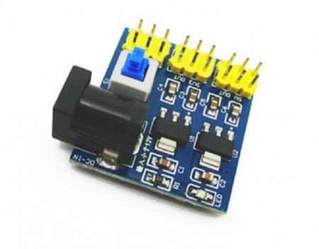

Click to Enlarge

**Description:**

**1.** **One Channel input: DC 6V - 12V (input voltage must be output voltage higher than 1V or more.)**

**2 .Triple Output: 3.3V (+ - 0.05v error), 5.0V (+ - 0.05v error), 800mA (load current must not exceed 800ma), 12V (12V input directly to the output)**

**3.Two sides panel design, layout.**

**4. Specially designed two pin mounting holes, can be directly fixed to the board extended tunnel experiments;**

**5. Multiple input and output pin, easy to use and connect;**

**6. PCB size: 4.5cm * 4.5cm**